Fall 2025 - Assignment 1 System Specification & Design Document
Submitted by: Isaac Ng

Summary:

System background and goal
This system is a text-based, AI-generated interactive story based on existing tabletop role-playing game (TTRPG) game rule for singleplayer. This system is targeted to experienced TTRPG player and aim to provide similar experience without the need of multiple participants.

A typical TTRPG game consist of one Game master and three to six players. Game master act as the judge and narrator to operate the whole game. His duties are i) Narrative and Storytelling, ii) Rule Adjudication, iii) non-player character (NPC) Management, iv) World-Building and campaign Design. This system uses multiple agents to replaces the game master role in a traditional TTRPG game.
Figure 1. An ongoing game in AI Dungeon.
There are some existing products in the market, that utilize the LLM to achieve dynamic storytelling. However, there are some unwanted behaviours which some improvements are targeted to made on this system.
To minimize the workload, this project will focus on the simplified rule of DND 5e, a pre-defined main character, and a short campaign with 3 stages.

Requirements
The baseline features consist of:
- Dynamic generated story based on user prompt and progress.
- Interactive control on the main character action.
- Ensure all action and story align with game rule.
The targeted improvements are:
- Avoid confusion due to invalid information from user.
- Avoid inconsistence in AI-generated information.
- Proactive action from non-player character (NPC), environment or storyline.

Design Document (MaSE)
The following is the Design Document using MaSE methodology.

Capturing Goals

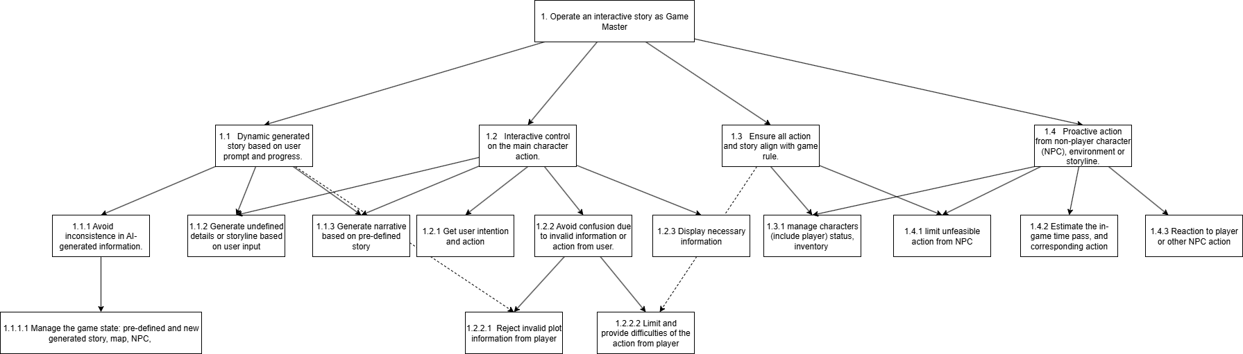
Goal Hierarchy

Goal Mapping:
- Interface Role: 1.2, 1.2.1, 1.2.2, 1.2.2.1, 1.2.2.2
- Narrator Role: 1.1, 1.1.1, 1.1.1.1, 1.1.2, 1.1.3
- Judge Role: 1.3, 1.3.1
- NPC Role: 1.4, 1.4.1, 1.4.2, 1.4.3

Applying Use Cases

Use Cases
Brief Description: | User input action or information to the system to progress the story
Precondition(s): | The game started, and the initial message was displayed
Post Condition(s): | The system displays and updates the narrative and the story progress.
Process Steps
1 | The Interface receives the prompt from the user, and passes it to Narrator
2 | The Narrator looks in the prompt and identifies the action.
3 | Narrator gets the action difficulty from the Judge and pass to interface.
4 | The interface displays the difficulty and is pending for player's decision. If continue the action, interface do a random roll to determine the success or not.
5 | Narrator generate correspond narrative base on result and inform the NPCs.
6 | NPCs evaluate correspond reaction and check its difficulty from the judge
7 | NPCs do a random roll to determine the success or not, and info the narrator the result.
8 | Narrator generates the NPC’s reaction narrative.
9 | Narrator passes NPC’s reaction narrative and user action narrative to interface
10 | The interface shows the narratives to user and progresses the story.

Sequence Diagrams
Use case are applied in the following sequence diagram. There is only one user in this system, but arbitrary NPC instance depends to the story.
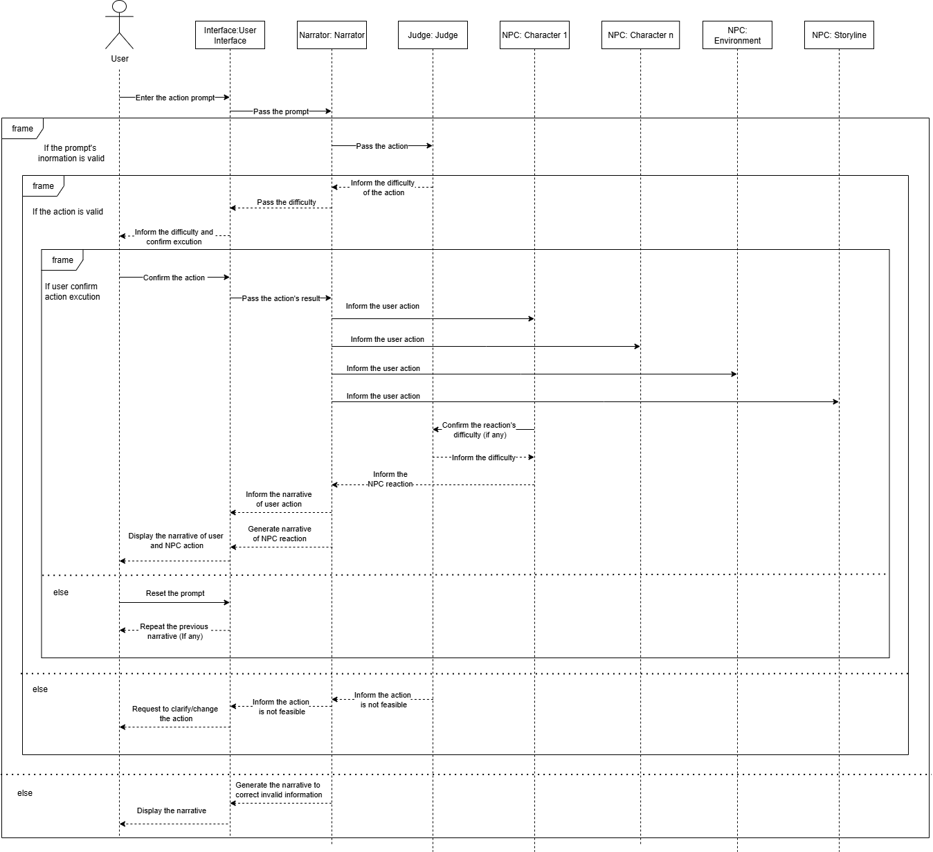

Refining Roles

Role Diagram
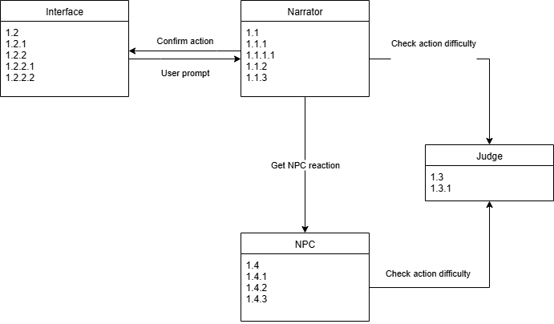

Role Diagram & Tasks

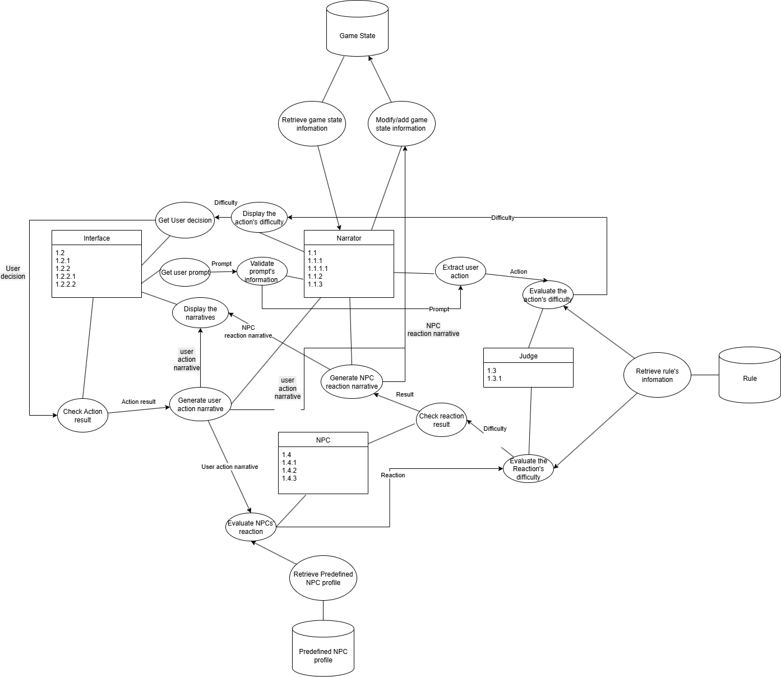

Creating Agent Classes

Agent Description & Agent Class Diagram
There are four agents in this system to simulate the game master functionality. Here is the detailed description of those four agents defined in previous diagrams.
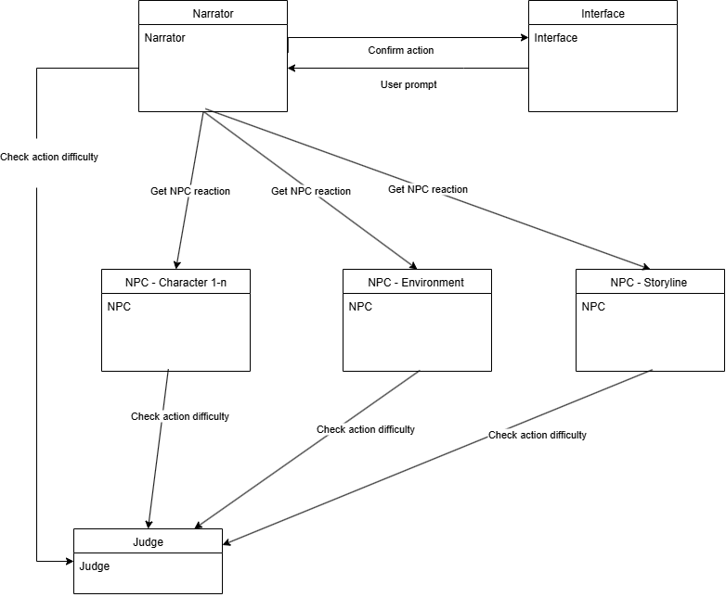
Interface Agent
- The interface agent displays the narrative generated by other agents.
- The interface agent displays necessary information, including main character (Health, Skill, Items), NPC (Health).
- The interface agent displays the difficulty of action (A number from 1 to 20, where a higher value indicates a more difficult action), and confirm the user’s decision.
- The interface agent does the difficulty check (randomizes a number—success if it's higher than the difficulty number).
Narrator Agent
- Narrator agent generates main character narrative based on pre-defined story and user prompt
- Narrator agent generates new details or storyline based on user prompt if the not contain in pre-defined story
- Narrator agent generates enemy reaction narrative based on pre-defined story and NPC agents
- Narrator agent keeps track and manages the game state information (previous prompt and conversation, NPC status, main character status, map).
Judge Agent
- Judge agent evaluates difficulty level of the action/reaction based on rule and reject unfeasible action/reaction.
NPC Agent
- NPC agent generates potential reaction to the main character or other NPC agents action based on the NPC profile (characteristic, status, background).
NPC Agent - Environment
- NPC agent - Environment generates potential reaction (trap, collapse, alarm) to the main character or other NPC agents action based on the pre-defined story.
NPC Agent - Storyline
- NPC agent - Storyline generates potential impacts on the storyline based on the main character's actions and the pre-defined story.
- NPC agent - Storyline estimates the in-game time passed during the action of main character and other NPC.

Agent internal architecture

Conversations
Get user prompt
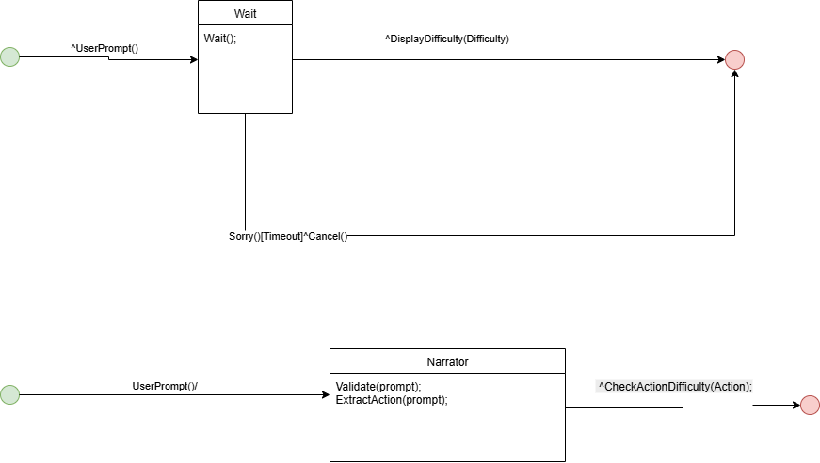
Check Action Difficulty
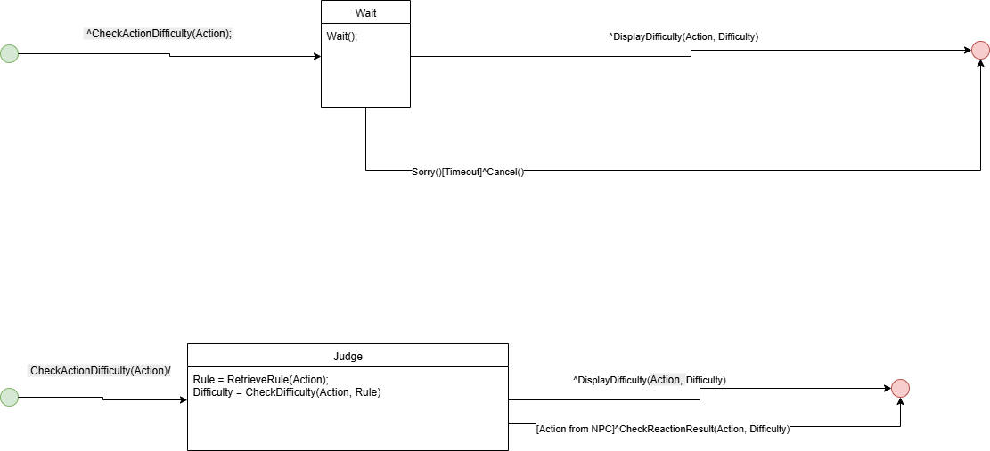
Display Difficulty

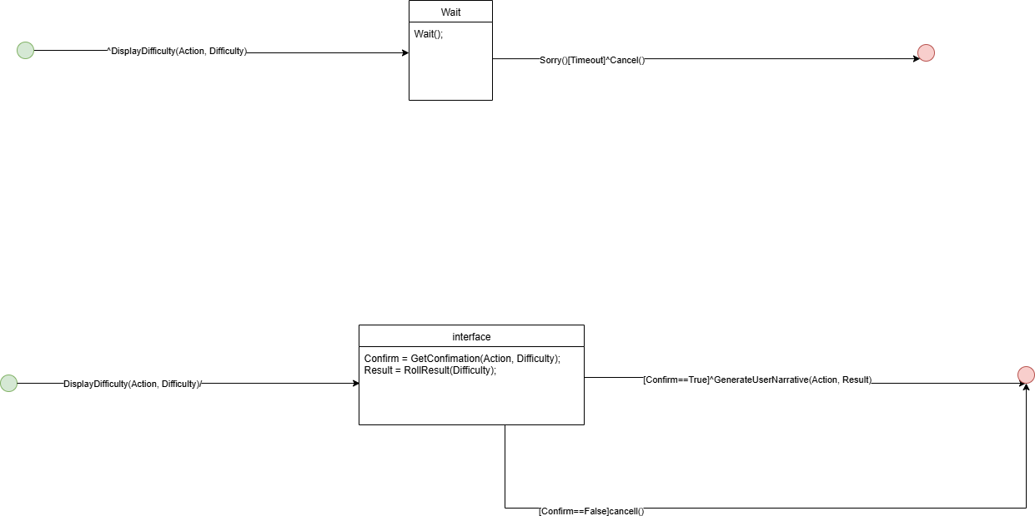
Generate User Narrative

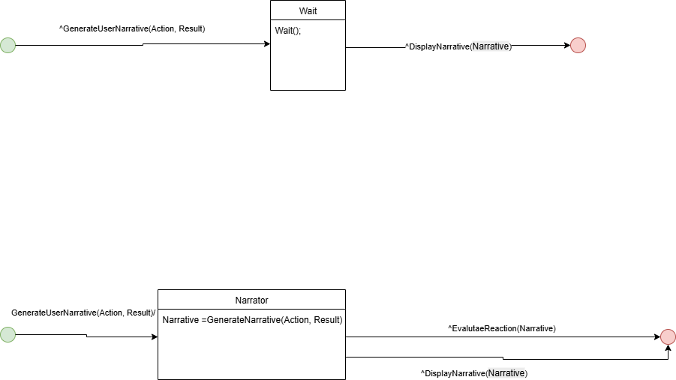

Evaluate Reaction
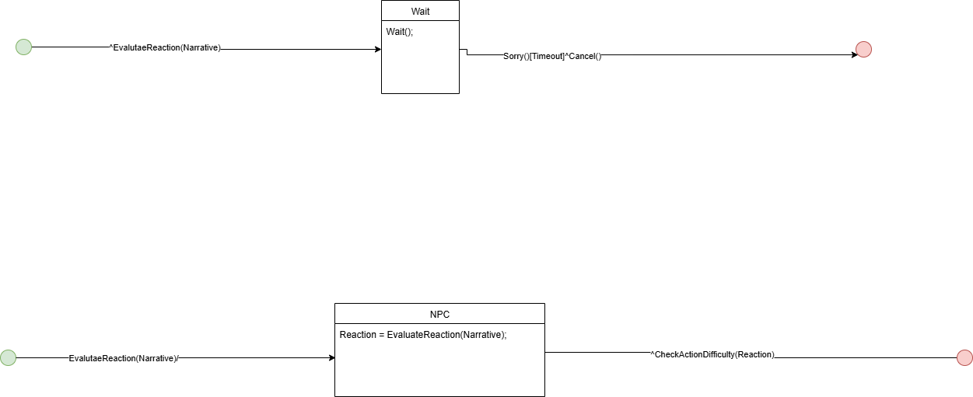

Check Reaction Result

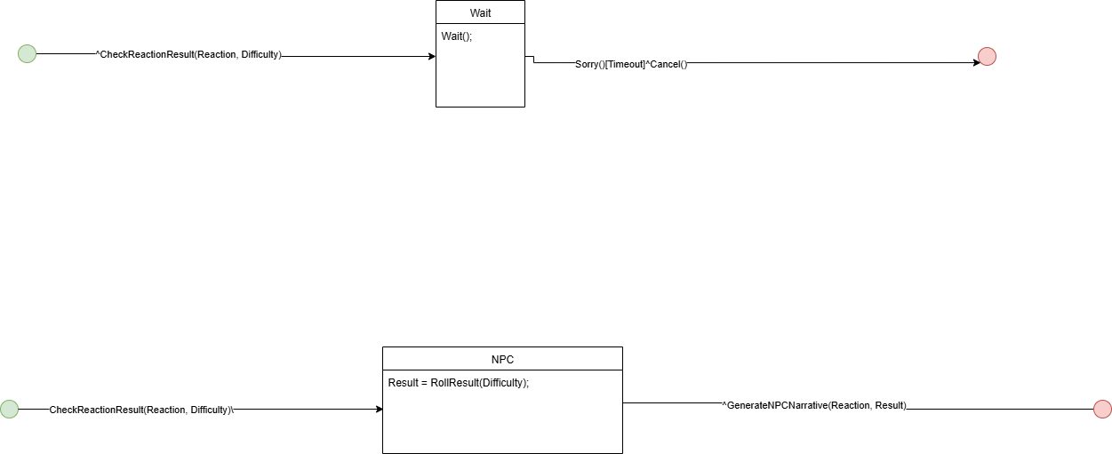

Generate NPC Narrative


Display Narrative
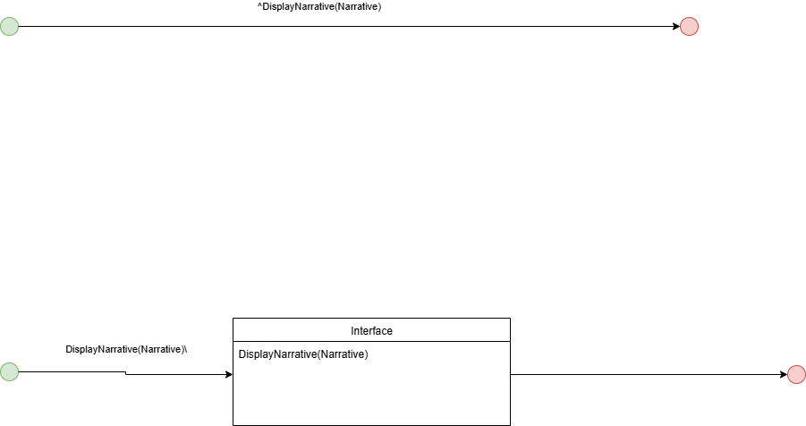

Deployment Diagrams
This system is intended to work cooperate with local GUI potentially in Java, and data (Rule, NPC, Items, pre-define story) in a vector database for RAG LLM potentially in crewAI.
